

Master of Engineering Management
School of Engineering
Course: EMEM535 - Managing Product and Service Development

NEW PRODUCT DEVELOPMENT:
Case of “Smart Kitchen Cabinet” product

Adil Kurmantas 201964924
Miras Mels 202010679
Sultan Nassiulla 201625797

Date of submission: 01.12.2025

Academic Year 2025-2026
1. EXECUTIVE SUMMARY 3
2. INTRODUCTION 3
2.1 Background 3
2.2 Purpose of the project 4
2.3 Tangible Objectives 4
3. OPPORTUNITY IDENTIFICATION AND CUSTOMER NEEDS 4
3.1 Opportunity Identification Process 4
3.2 Project Charter 5
3.3 Mission Statement 5
3.4 Market Analysis 6
3.5 Identifying Customer Needs 7
3.6 Concept Alignment 8
4. CONCEPT GENERATION 9
4.1 Problem Decomposition 9
4.2 External Search 9
4.3 Internal Search 10
4.4 Systematic Exploration and Possible Concepts 10
4.5 Concept Selection 11
4.5.1 Concept Screening 12
4.5.2 Concept Scoring 13
5. CONCEPT EVALUATION AND TESTING 14
5.1 Customer Testing 14
5.2 Market Demand Estimation 14
6. Recommendations 15
References 16

1. EXECUTIVE SUMMARY
As a team we are tackling the ultimate kitchen challenge with the "Smart Kitchen Cabinet" (SKC). We figured out that even with all the dishwashers and smart cookers in today's homes, something was missing. There is still this huge gap in handling everything from storing food to getting a cooked meal right on your plate. Our market research backs it up, showing that almost 98 percent of the households we surveyed really trust automated cooking tech. Folks seem ready to swap out their everyday kitchen chores for extra free time, along with way less food waste.
After concept evaluation, we decided to drop the whole notion of those fancy robotic arms that need constant upkeep. We went with a solid vending system approach instead, what we call Concept C. Picture it like a clever fridge teamed up with an exact automated cook. It relies on standard capsules and steady linear actuators to grab ingredients, portion them out, and prepare meals all on its own. We designed the SKC just for families of two or three people. It works as your personal stock keeper and chef combined, keeping food fresh while making sure meals stay nutritious.
The product seems financially viable. We ran the numbers through a basic purchase probability model, and it points to over eight thousand units sold each year. Since this high-tech item demands a lot of research and development, our plan is to kick it off with a premium crowdfunding push. That way, we can team up with eager early users who are excited to back the next step in kitchen automation. The SKC goes beyond a simple gadget. It offers a real step ahead, handing back your time and helping maintain solid nutrition.

2. INTRODUCTION

2.1 Background
The Industrial revolution of the XX century taught us that no profession is safe, and any human labour can be replaced. The technological leap in robotics extended that to the point of “any human labour will be replaced”. With the development of AI tools, we can clearly see how fast are we progressing to that exact point in history, where all the hard labour will be delegated into ice cold metal hands of machines. On the other hand, people will have more time on their hands to practice philosophy, art, and work of their choice.
With this thought in mind, our team decided to try our best in an attempt to optimize our daily routine by automating kitchen labour. Surely, tools like dishwashers, rice cookers and thermomixes help us a great deal. Nonetheless, we believe that there can be a product that will automate a whole process of preparing a meal.

2.2 Purpose of the project
Our project aims to create a concept of a product that can be fit into a kitchen of a regular apartment, conserve food, manage inventory, and most importantly - prepare meals for their users, addressing issues of time efficiency, diet consciousness, and waste free production.

2.3 Tangible Objectives
Our team aims to deliver outcomes of the project as instructed in the syllabus - in the form of a project report, midterm and final presentations. Within the scope of work we aim to generate a lot of ideas and features, filter them out and finalize a product concept by using the knowledge and techniques we have acquired within the course.

3. OPPORTUNITY IDENTIFICATION AND CUSTOMER NEEDS

3.1 Opportunity Identification Process
This stage of the Product development process is one of the important and influential parts of the whole process. The aim of which is to identify your primary opportunities that need your time, consideration as well as investment. Inspired by our Product development literature from our course, in our project Smart Kitchen Cabinet, we have used methodology “tournament structure” that clearly defines the gap between existing products and current market needs. Thus, at the beginning of the project, we as a team started with writing numerous raw ideas related to automated home appliances. Through our systematized approach, we found that the kitchen appliances sector has much more untapped market needs than others. Let’s look into this kitchen sphere, nowadays people have automated cooking equipment from brands such as Thermomix, Kenwood, etc., also have special softwares for meal planning and healthy diets. Moreover, consumers have highly developed refrigerators that consist of innovative features with integration of advanced technologies such as recognition of food expiration dates and so on. By analyzing all of these existing products with a team, what we really wondered is that we have very well evolved equipment, but none of them has an integrated system that does all of these product needs through one appliance and without human alteration. In simple words, we came to the point that we have to explore the opportunity to integrate the significantly developed food storage, automated meal preparation together with software for meal planning with the purpose to have all of these functions integrated in one equipment. Going further, this became the primary focus of our project.

3.2 Project Charter
Product vision: integration of AI powered food recognition system and food storage with equipment that delivers a meal as a final product.
Product description: automated kitchen equipment that actively utilize mechanical actuators, isolated capsules, many kitchen devices and other mechanical supports with smart AI chips to optimize the food resources and prepare the meal.
Benefits: Effort minimization, Resource Management, Life Quality.
Key goals: Market acceptance, final Product design, Sales volume.
Primary market: households with 2-3 people.
Secondary market: households with larger numbers of people, mostly 4-6 people.
Assumptions and Constraints: advanced technology utilization, food storage, ecosystem connectivity, physical product size.
Stakeholders: Project team, end users, food manufacturers and shops.

3.3 Mission Statement
The mission statement phase of any product development is the crucial part as it defines the scope and main goals of the project. Let us clarify the initiative’s mission that our project should pursue. Mission is to integrate AI powered food recognition and storage with robotic conveyor systems for full meal preparation and execution. This kitchen equipment attempts to solve the minimization of human efforts, benchmarking for simple meal planning and preparation, and to solve the food waste issue. With this approach, Smart Kitchen Cabinet proposes a unique opportunity of “Life Quality Enhancement” , which delivers cutting edge competitiveness because of the delegation of routine meal preparation, food resources optimization and integration of all of these functions in one physical object.

3.4 Market Analysis
In this section, we should understand the market that we are eager to enter, also analyze already existing products, and define the consumers' needs and wants. As we have stated in the previous sections, the market has two different equipment, one for food storage and the another one for meal preparation. But, there is a gap between these two appliances, and closing this gap by integrating them as an one ecosystem could be an ideal fit for the Smart Kitchen Cabinet product’s value proposition. To get statistics, clear market expectations, we created our first survey and conducted it for different sizes of households. The survey results showed that half of the respondents were from households with 2-3 people, the other 34.1% showed households with 4-6 people. This data suggests us to put them as a primary audience. Additionally, the important factor for market interest is the potential consumers’ trust on the equipment, and results showed that 56.8% replied ‘Yes’ and 40.9% replied ‘Maybe’. Overall these indications demonstrate 97.7% of households trust this kitchen appliance.
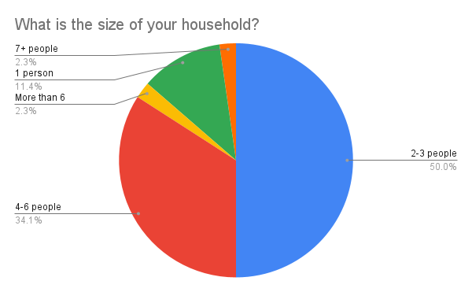
Figure 3.3.1 Pie chart representation of household sizes within survey respondents.
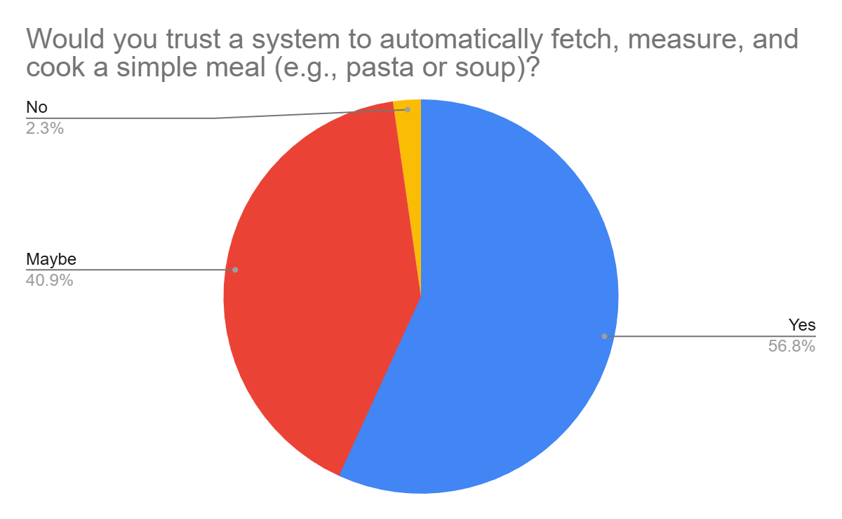
Figure 3.3.2 Pie chart illustrating that a significant proportion of the survey respondents incline to trust new automation technologies in order to prepare their meals.

3.5 Identifying Customer Needs
We have searched for the academic sources that did research on this area. Found different sources that cover the food waste problems and the ways to eliminate them. For example, one initiative discusses the IoT technology within fridges for food resources optimization. Even though we could not find the academic paper that does research on the integrated smart appliance for households. This means that we have latent needs that should be addressed as soon as possible.
Returning back to our first survey, we have included various features of the kitchen appliance and asked to rate them. As a consequence, we have got the three aspects that have a high impact, they are Convenience and Time saving, Inventory freshness, as well as smart home system connectivity.
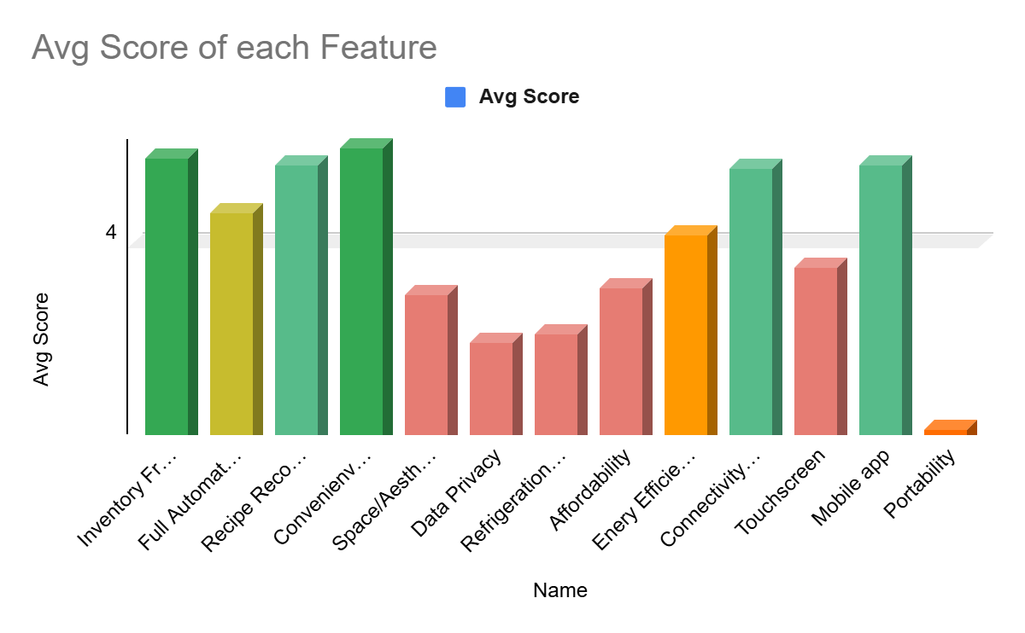
Figure 3.4.1 Histogram of average score of importance given by survey respondents, put in a logarithmic scale in order to visually clear out the “most important” features from the ones that got assessed as less important by the respondents.

3.6 Concept Alignment
In the previous sections, we have done our own market analysis and survey to get clear understandings about the customer needs. Thereafter, following the approach from the Product development book, we have constructed the hierarchy of needs. To construct this table, we have divided needs into three levels, and respective eight need categories. The number one priority or primary need for our consumers is a life quality enhancement. Moving on, we have secondary needs with three categories as well as tertiary needs with four categories. The important point to mention is that secondary needs consist of effort minimization, resource management, and integrated ecosystem which are placed from high priority to low. By effort minimization, we mean the convenience and time-saving, by resources management, we mean the inventory freshness and food waste optimization, by integrated ecosystem, we mean the connectivity to smart home systems for our consumers through our product. All of these were done in order to convert the consumer needs to measurable metrics. Below, you can see the table for hierarchy of needs.
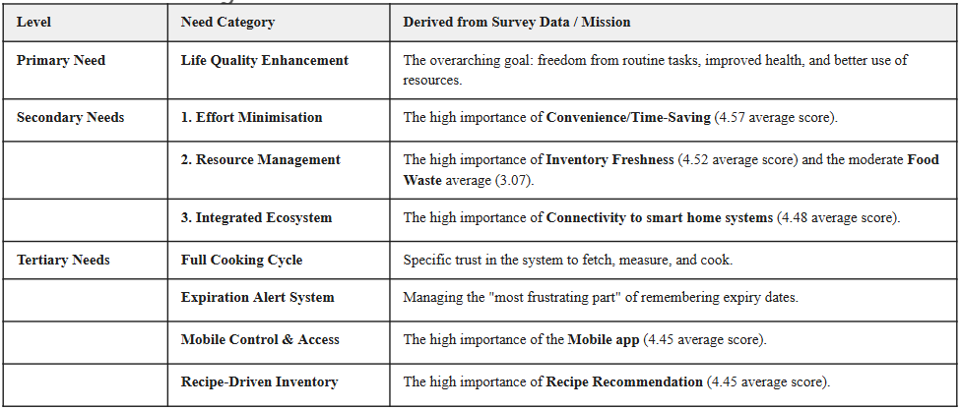
Table 3.5.1 Primary, secondary and tertiary consumer needs table.

4. CONCEPT GENERATION

4.1 Problem Decomposition
When we think about the Smart Kitchen Cabinet equipment, we mostly associate it with big equipment that takes large space and think that it is an extremely complex system. In order to simplify this problem, we divide one whole problem into sub-problems and via them we assure ourselves that our product is not complex as we thought at the beginning and it is real to develop. We are using a high level visualization method called functional diagram which illustrates the main inputs and outputs from the system. You can see from the image below that we have inputs in the form of energy, food and internet and outputs in the form of energy, prepared meal and food assessment.
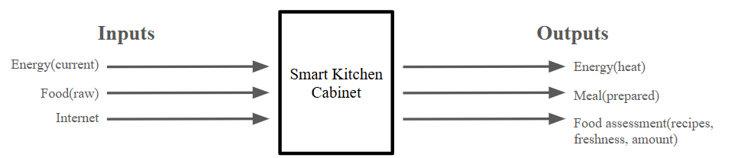
Figure 4.1.1 Functional diagram of Smart Kitchen Cabinet.

4.2 External Search
Automating the cooking process, be it fully or partially, has been a goal of many innovative companies worldwide. Being motivated by a number of reasons, such as health concerns in the younger population[2], or democratization of nutrition knowledge [3], leading to our common goals as rising environmental and economical efficiency of cooking processes.
Additionally, AI Food Pantry, and the vast variety of similar applications on platforms like AppStore and Google play serve as a proof of market demand in AI assistance in inventory management. The further search in similar technical solutions to ours revealed products as CA-1 Series 4 System by Circus SE [4], US Army dining facility in Republic of Korea [5], Posha - the portable autocooker startup[6], and the Thermomix Tm7 [7].
The aforementioned technologies provided us with feature ideas such as standardized food storing, and a conveyor-like boxy design. Moreover highlighting the importance of features as connectivity to mobile devices, and AI integration for inventory management and recipe recommendations. The external search also highlighted the gap in the technologies required to execute the concept. However, we believe that the most recent advances such as in the CA-1 Series and the US Army dining facility are proof of the correct direction that our team has taken in order to accomplish cooking automation[4, 5]. Since products like Posha are still in the stage of startups, and there are no physical products delivered to the users, we believe that our innovative approach is still relevant to the mass market, as solutions from Circus SE and US army are not developed for the common market as for now [4, 5, 6].

4.3 Internal Search
To address the most challenging issues related to product design and construction, we listed three main sub-functions that we should concentrate on and propose any mechanical concepts to solve them. For the first sub-problem of moving foods within the system, we can implement concepts such as Modular Cartridge System, Gantry Crane or Robotic Arm, or Vertical Carousel. All of them use different mechanical elements, but with the one purpose of moving food. For the second sub-problem that related to the measurement methods, we have offered Gravimetric Hopper, Peristaltic Pump Array, and Visual Confirmation Dosing with the primary objective to measure the ingredients in meal preparation. For the third sub-problem, to prepare the meal we should have a number of devices within the system, and most importantly have Sonic/Ultrasonic Slicer, Multi-Axis Planetary Mixer, Mortar and Pestle Grinder.

4.4 Systematic Exploration and Possible Concepts
In this section of the project, we have implemented a concept classification tree to show the main attributes of consumer needs. The tree was divided into four categories, core inventory and function, automation and convenience, hardware and aesthetics, ecosystem and business. In the image below, you can see the image of the classification table.

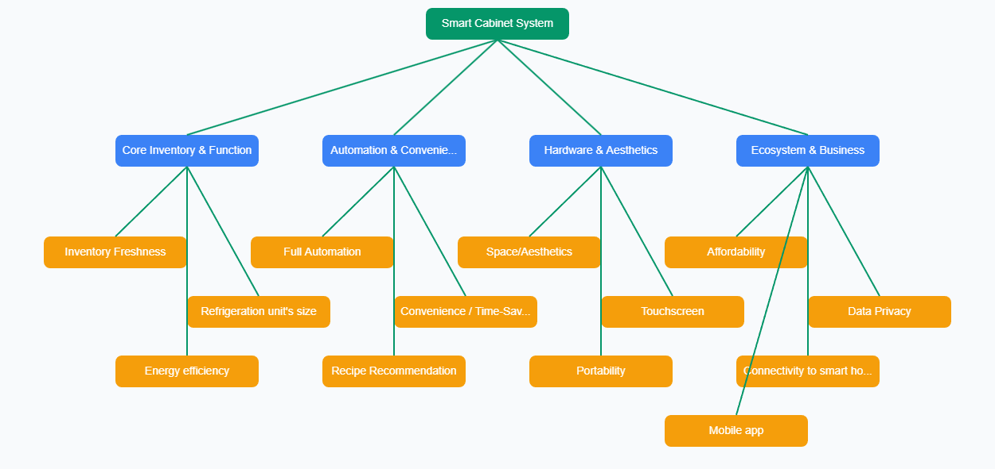
Figure 4.4.1 Concept classification tree.

Following the classification table, we have developed three product concepts A, B, and C which cover all the attributes. Let us clarify each of the product concepts. Product A called Premium Robotic uses a complicated robotic arm sub-system with high flexibility, at the same time it is a complex system with high cost. Product B called Modular Carousel uses a rotating Paternoster/Carousel element to move the ingredients within the system, but has mechanical risks due to complexity of the design. Product C called Vending System uses mechanical linear actuators and it accounts for standardized approach in the engineering field, also to mention it gives much better reliability compared to others.

4.5 Concept Selection
With regard to conducting internal and external searches along with customer needs identification, we have come up with the following concept ideas for the concept selection phase.
Concept A: a robotic arm that is installed in the kitchen that is attached to a ceiling and can fetch ingredients from the storage, simulating a human presence in the kitchen.
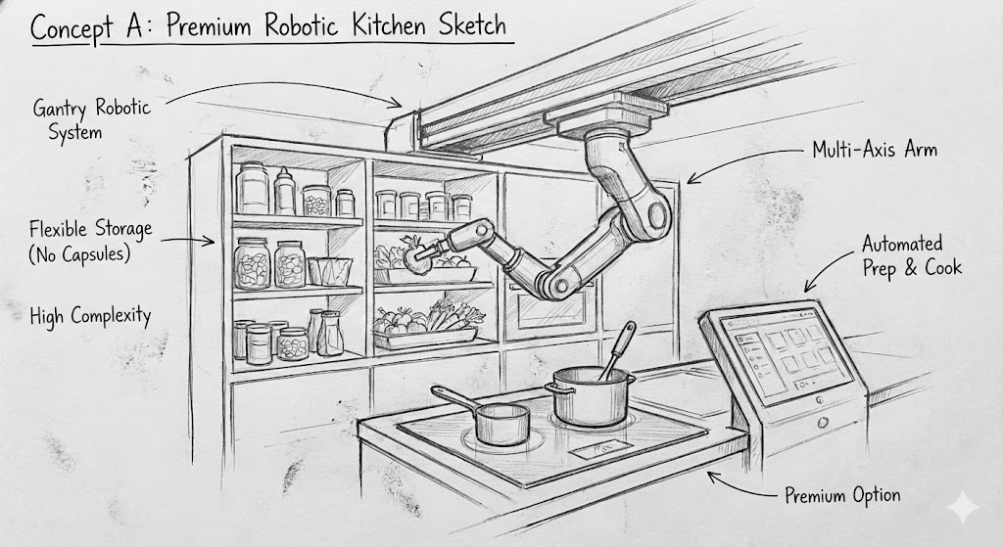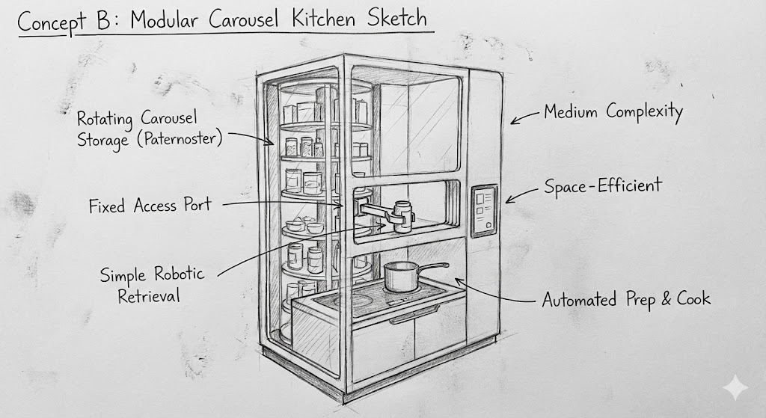
Figure 4.5.1-2. AI-Made sketches of the concepts A and B.
Concept B: A modular cabinet with a carousel inside that distributes prepared food as a vending machine.
Concept C: A modular cabinet resembling a fridge with a meal preparation compartment behind it with a take-out window and a display.
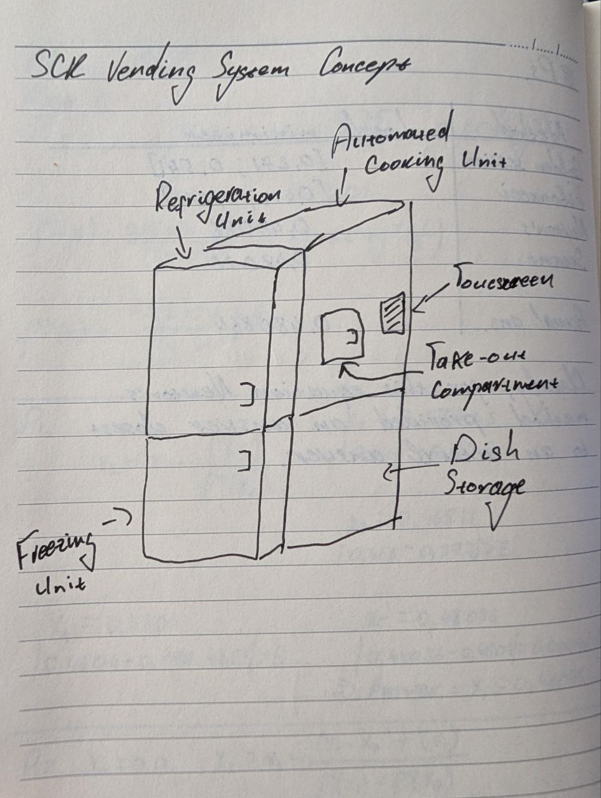
Figure 4.5.3 Hand-Drawn sketch of the concept C.

4.5.1 Concept Screening
For the concept screening we have selected Posha as our reference model, because it is the least technologically complicated product that is also oriented towards personal usage in homes. We have put the concepts and the reference alternative inside a screening matrix.

Criteria | Weight | Posha | Concept A: Robotic Arm in the Kitchen | Concept B: Modular Carousel | Concept C: Vending System
Convenience/Time-Efficiency | High | Reference | + | + | +
Inventory Management | High | Reference | 0 | + | +
Recipe recommendations | High | Reference | + | 0 | +
Connectivity to Smart home systems | Mid | Reference | 0 | + | 0
Mobile app | Mid | Reference | - | + | +
Technical Complexity | High | Reference | - | - | -
Sum (+) |  |  | 2 | 4 | 4
Sum (0) |  |  | 2 | 1 | 1
Sum (-) |  |  | 2 | 1 | 1
Net Score |  |  | 0 | 4 | 4
Decision |  |  | Eliminate | Proceed | Proceed
Table 4.5.1.1 Pugh matrix for concept screening
Besides the identified feature set, we also added the Technical complexity as an important feature. However after filling out the matrix we realized that all of our concepts would be more technically complex than Posha.
As a result of analysis, Concepts B and C proceed to the next stage - concept scoring.

4.5.2 Concept Scoring
For the concept scoring we created one more matrix, but this time we scored the features for each concept according to the extracted weightings.

Criteria | Weight (W) | Concept B: Modular Carousel (Rating - R) | Concept B: Weighted Score (W$\times$R) | Concept C: Vending System (Rating - R) | Concept C: Weighted Score (W$\times$R)
Convenience / Time-Saving | 0.3 | 4 (Very Good) | 1.2 | 4 (Very Good) | 1.2
Inventory Freshness | 0.25 | 4 (Very Good) | 1 | 5 (Excellent) | 1.25
Reliability | 0.15 | 4 (Very Good) | 0.6 | 5 (Excellent) | 0.75
Cost / Affordability | 0.15 | 3 (Moderate) | 0.45 | 4 (Good) | 0.6
Footprint/Complexity | 0.15 | 3 (Moderate) | 0.45 | 4 (Good) | 0.6
Total Weight | 1
Final Score |  |  | 3.7 |  | 4.4
Table 4.5.2.1 Concept Scoring matrix
As a result, we are moving forward with the concept C. It heavily resembles the industrial automation solutions, however this is our best attempt to also imitate familiar technologies into the kitchen space, as this concept resembles a fridge with an additional compartment.

5. CONCEPT EVALUATION AND TESTING

5.1 Customer Testing
Following the previous sections, we have concluded that the Vending System will be our foundation for the SKC design. In this phase, we have created our second survey and gathered responses to confirm that especially this design will bring value to our consumers. The survey was structured in a simple way to just evaluate the concept. Questions covered the main advantage of this product design, and overall about their thoughts on this product. As a result, we have received 30 responses, and it showed that on average 4.5 out of 5 is readiness to purchase this appliance, whereas 4.33 out of 5 score is for the food storage satisfaction, and readiness to use this technology 17.13 times for meal preparation per week.
 | How likely are you to purchase the SKC if it were available at a reasonable price? | How satisfied are you with the idea of storing ingredients in sealed, standardized capsules for freshness? | How many meals per week do you estimate you would use the SKC to prepare?
AVG | 4.5 | 4.333333333 | 17.13333333
Table 5.1.1 Average scores given by survey respondents to the questions.

5.2 Market Demand Estimation
Using the common formula for the market sale estimates, we have evaluated the sales. The formula is Q = N × A × P model. Let’s decompose and give an explanation for each element of the formula.
Q - annual sales
N - number of purchases in one year
A - coefficient for awareness
P - probability of purchase
In our case, to find the Q, we assumed that we have 50,000 households who are interested in our product. Also, we assumed that 1 out of 5 households are aware about this feature and got 0.2 for this coefficient. The last term is probability of purchase which is assessed through the questionnaire and on average it is 0.8387. Then, we put all the numbers to the formula and got the 8387 units per annual sale. It could be a rough calculation, but still it gives us a preliminary forecast on our product’s sales measure.

6. Recommendations
The Smart Kitchen Cabinet represents a feasible leap in home automation. By pivoting from complex robotics to a robust "vending" style architecture, the project addresses the "latent needs" of modern consumers who seek to reclaim time lost to daily cooking routines while maintaining control over diet and food freshness.The final product is technologically advanced, complicated, and has high financial demand in investments in order to be shipped onto the market. However besides that we see an opportunity to create a real life crowdfunded startup that can serve the higher end of the market initially.
Considering the profit market being rich people, we believe we can set higher profit margins per unit sold, cause our initial customers don’t buy the product only, but also contribute to the future of cooking automation by supporting this project.
In order to avoid discrepancies and product underperforming on market, the crowdfunding opportunities will have minimum entry requirements that will guarantee that the initial investors will have the product shipped to them. In case the initial investments fall short of meeting the minimum set benchmark, the money will be returned and the idea will be reformed accordingly.

References
[1] Smart Fridge Monitoring to Reduce Food Loss and Waste (ResearchGate).
[2] Gao, Xiaoyan & Ding, Xiangqian & Hou, Ruichun & Tao, Ye. (2019). Research on Food Recognition of Smart Refrigerator Based on SSD Target Detection Algorithm. AICS 2019: Proceedings of the 2019 International Conference on Artificial Intelligence and Computer Science. 303-308. 10.1145/3349341.3349421.
[3] Tripathy, Debasish (2024). AI Food Pantry Our Mission. Retrieved from https://www.aifoodpantry.com/mission
[4] Donlon, Marie (24.11.2025). Autonomous AI kitchen cooks and serves 120 meals an hour. Electronics 360. Retrieved from https://electronics360.globalspec.com/article/23069/autonomous-ai-kitchen-cooks-and-serves-120-meals-an-hour
[5] Corey, Anthony & Keay, Deziree (21.11.2025) US Army pilots first autonomous dining facility in South Korea. US Army. Retrieved from https://www.army.mil/article/289125/us_army_pilots_first_autonomous_dining_facility_in_south_korea
[6] Posha. (2025). Retrieved from https://www.posha.com/home-2
[7] Thermomix (2025). Retrieved from https://www.thermomix.com/pages/thermomix-tm7

